**Deep Learning**

**Artificial Neural Network**

**Neural Networks Intro: for Single Hidden layer**

How to draw neural networks?

Simple we can draw lines from each Input values points to each hidden layer values points.

X = x1, x2, x3, … xn 🡪 Futures (rows or columns depending on the context)

*W = w1, w2, w3, … wn* 🡪 Weights **(1st random values assign to work with hidden layer)**

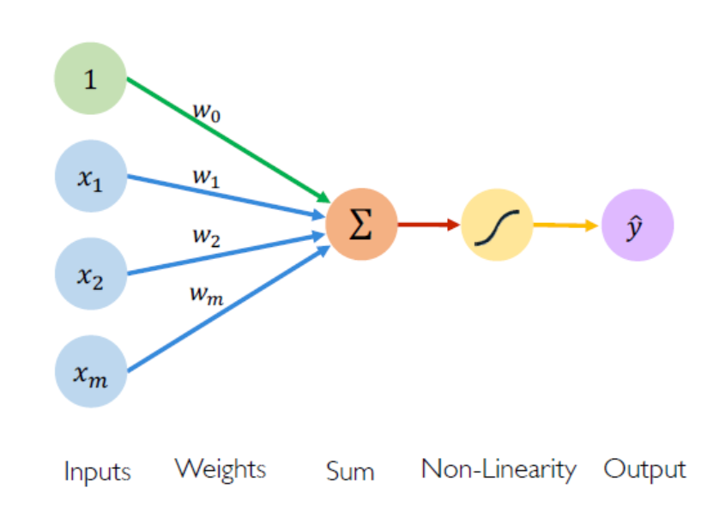

Z = Z+W4 = ŷ

W4

Z = Act(y)

**Activation Function (Z)**

* Sigmoid
* SoftMax
* Tanh and ReLU…

**Prediction**

(Predicted Value)

Y = w1*x1  + w2 *x2  + w3*x3 … + Bias

**Hidden Layer**

This process iterates multiple time with different weights by updating

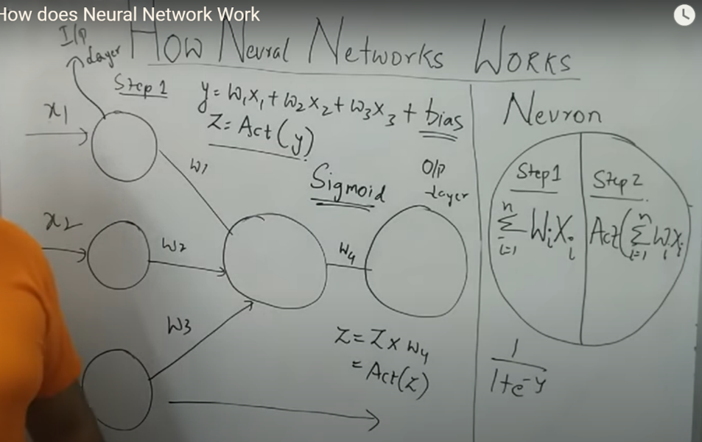



Here in the beginning, **random weights are assigned to the input variables** and summation happens in the hidden layer. And once the Y is formed. It is added in activation function.

Y = w1*x1  + w2 *x2  + w3*x3 … + Bias

* Y = 🡪 in short formula for above expression

Y = Hidden Layer 🡪 summation value of input variables and weights.

Bias = Underfitting, poor performance on both training and test data. Result in error

Then this Y value is added in activation function.

Ex: Sigmoid Function

**Z =1 / 1 – *e -y***

Then again, the Z value added with another weight which is W4 Which is the result or predicted output value.

Z = Z+W4 = ŷ

[Krish Naik YouTube](https://youtu.be/JkeiEYkLEvM): Tutorial-2

**Activation Function:**

1. **Sigmoid Function**

**Z = 1 / 1+ e-y** 🡪 y is from above formula, Z is predicted value

If Z >= 0.5 = 1

If Z <= 0.5 = 0

If Z = 0.5 = 0 🡪 it takes the threshold value ceil (0.5) and gives 0 as the result.

Y = 🡪 this is the summation of all the input values with weights then

Act(y) adding this y value to the activation function

**Z =1 / 1 – *e -y***

Then we will get the output as o or 1.

* Mostly used for binary classification problem at the end layer.

1. **ReLU: Rectified Linear Unit**

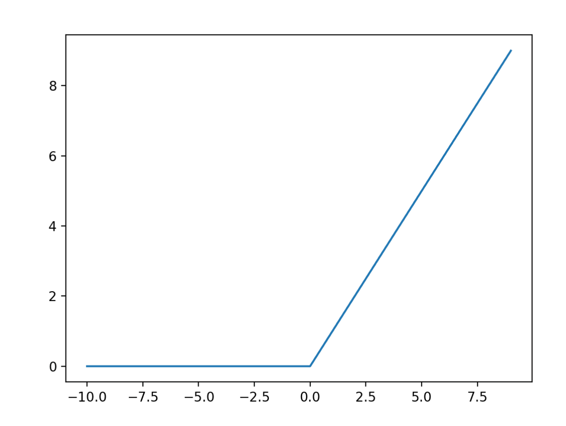

ReLU = max(y,0)

Act(y) 🡪 adding summation of input values and weights to the activation function ReLU

***max(y,0)***

If y = negative value, then the max value is 0 so output is 0

If y = positive value, then the max value is not 0 and max value is y.

Here

Y = 2, then output is 2

Y = 3, then output is 3 same way it gives the y as the output if the y value is positive.

* Mostly used for regression problems at the end layer.
* Also used for classification problems at the hidden layer but in the end, we go with sigmoid function only for binary classification, but ReLU can be used in hidden layer.

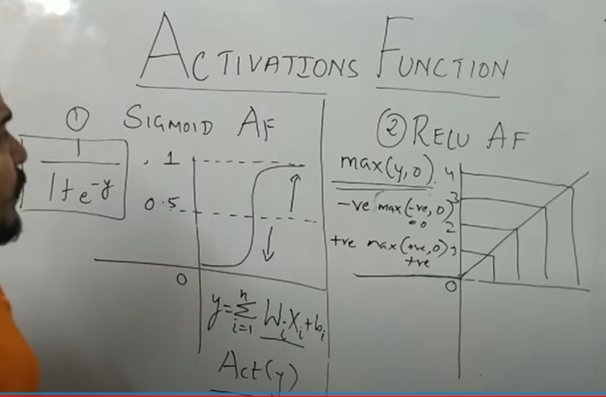

[Krish Naik: Tutorial-3](https://youtu.be/SXrXUqDjICA)

**Forword Propagation:**

Initially Random weights are assigned to the input values and summation happens in the hidden layer and forwarded to the activation function. (This process happens with each hidden layer of the NN) Then let’s say, for example, we have sigmoid function. So here the output will be zero or one.

Let us say in original data set, the actual output value is one (1) And my model is predicted as zero (0).

These steps are already discussed in one and two pages.

Y = 1 but ŷ = 0 🡪 this is Error

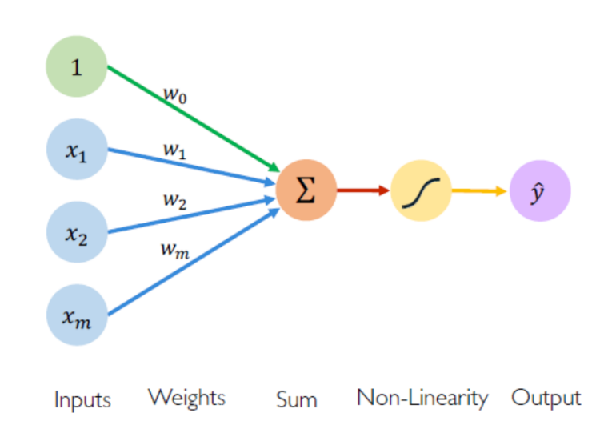

Now we have to implement the Loss function

MSE = (y- ŷ)2 🡪 (Actual – Predicted)2

Square is used to normalise the negative value and shows the positive value as the error difference

Here in our problem error is 1, (100%) which means completely different value to the actual value.

By defining the loss function, we will get to know that the error level to reduce the loss/minimise the loss we use Optimisers like Learning rate etc…

In training phase, we will be updating such a way that to reduce the error with the help of Optimisation.

Now here comes the Back propagation to reduce the error/for better accuracy by updating the weights.

**Back Propagation:**



How are those weights updated?

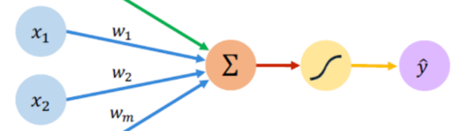

***w4***

In back propagation, the weights are updated in such a way

***w4 new = w4 old – η \**** ∂***L/***∂***w4***

W4 new = New weights

Learning rate = *η*

∂*L* = Derivative of Loss (L)

*∂L/∂w4* = Loss Function (L) of w4 in derivation

Similarly

***w3 new = w3 old – η * ∂L/∂w3* || *w2 new = w2 old – η * ∂L/∂w2 …***

This Process updating weights are iteratively happens (Repetitively happens multiple times. With different learning rate) to achieve the maximum possible outcome with minimum error or no error.

A book given last function is used for a single value. But when it comes to the multiple values or the entire data set, we use Cost function.

**Cost Function:** Sum(Actual – Predicted)2

**MSE =**

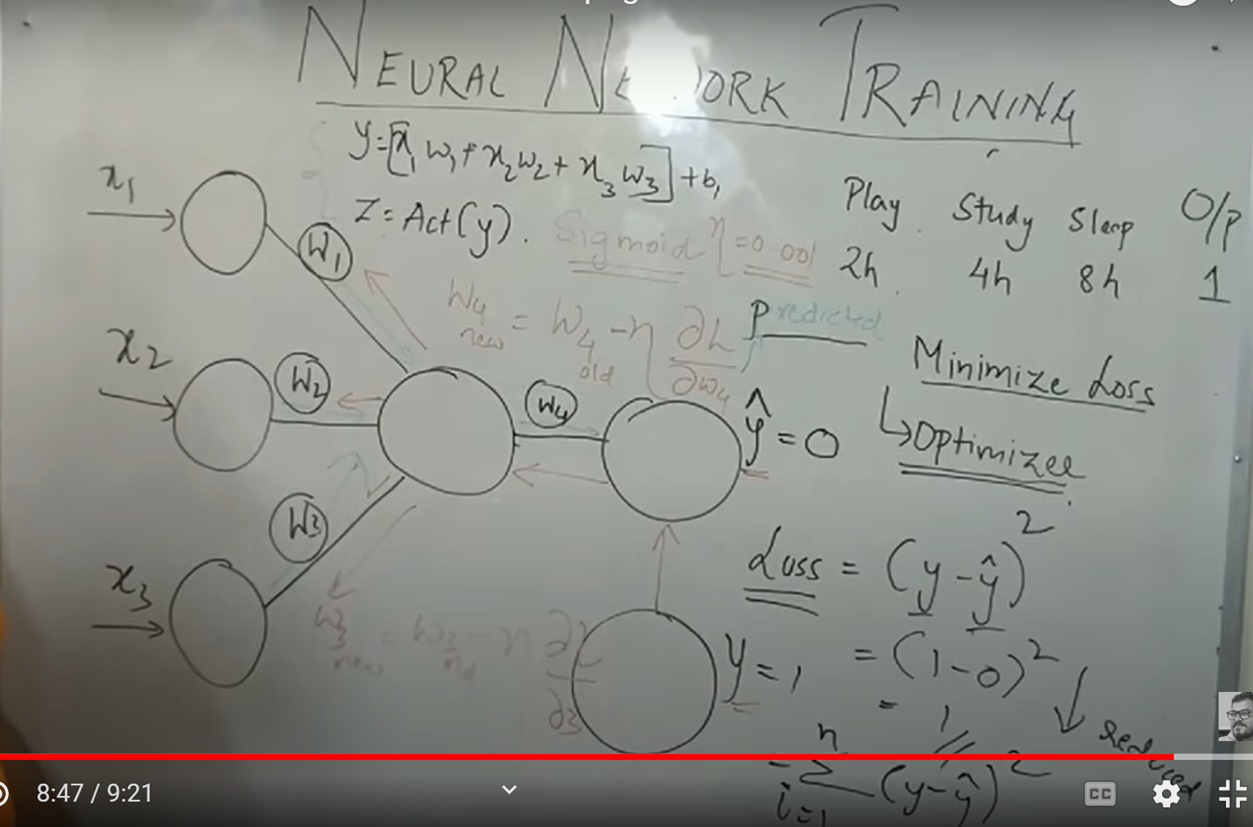

[Krish Naik: Tutorial 4](https://youtu.be/mH9GBJ6og5A)

**MNN: Multi Neural Networks:**

It works as same as single neural network works, but it contains multiple hidden layers with multiple neurons. One another. From the input layer.

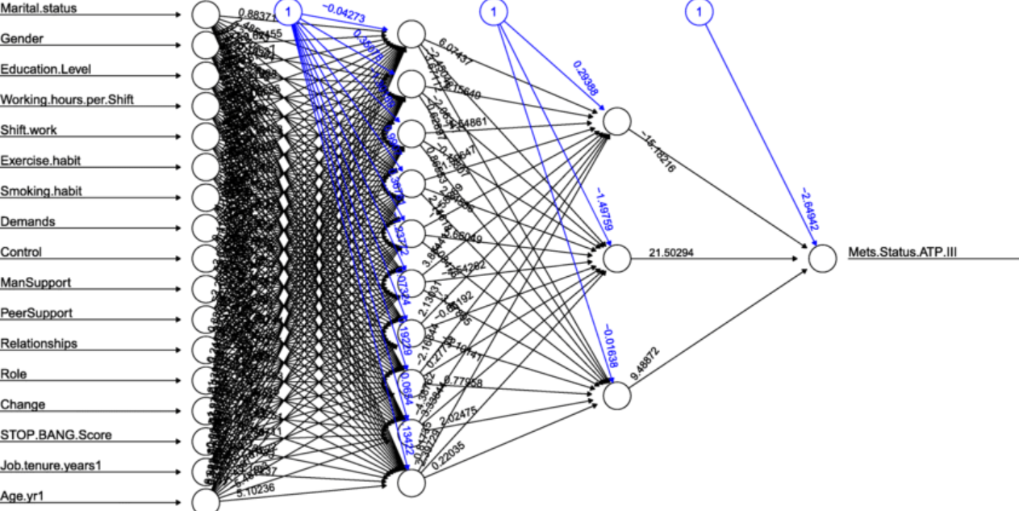

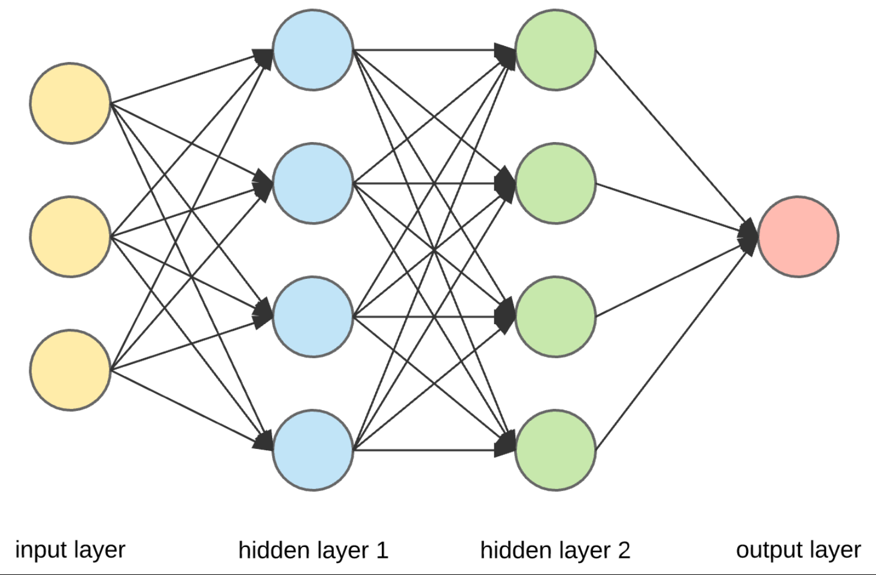

***O33 1***

***f3 1***

***W11 3***

***W11 4***

***W11 2***

***W11 1***

**Loss Function**

**Learning Rate**

Optimiser

**Back Propagation**

***W3 2***

***W3 3***

***W3 4***

***W3 1***

***O4 4***

***O4 3***

***O4 2***

***O4 1***

***O3 2***

***O3 4***

***O3 3***

***O3 1***

***O2 3***

***O2 4***

***O2 2***

***O2 1***

***O1 4***

***O1 3***

***O1 2***

***O1 1***

***W3*** 4

***W3 3***

***W2***  2

***W3 2***

***W2 3***

***W2 4*** 4

***W2 1***

***W3 1***

***f2 2***

***f2 3***

***f2 4***

***f2 1***

***f1 4***

***f1 3***

***f1 2***

***f1 1***

**X2**

**X0**

**X1**

X = Input Layer

W = weights from input layer to hidden layer 1

***f*** = Hidden layer

O = Output values after activation function is applied to the hidden layer 1

Z = Activation Function (applied in each layer to each node using weights and bias)

$\text{ŷ}$*=* Predicted Value

Red arrow( ) = Back Propagation

Layer number

*w12 1*

To point

from point

W111 🡪 1st layer’s 1st point to 1st hidden layer’s 1st point

W121 🡪 1st layer’s 2nd point to 1st hidden layer’s 1st point

Similarly

W212 🡪 2nd layer’s 1st point to next layer’s 2nd point

W2  🡪 here this exponent represents the layer index or number

W12 🡪 here this base represents the respective layer’s point to the next layer’s point.

In the beginning, each weight randomly are added along with the input layer and summation happens in the hidden layer The summation value, which is Y, is added into activation function. Then the output is predicted then comparison with the actual value to the predicted value, which we say, loss function is calculated. Then to reduce the loss with the help of learning rate, we back propagate the neural networks.

This back propagation happens forward propagation happens multiple times in an iterative way, with changing in weights. With the help of weight upgradation formula.( ***w4 new = w4 old – η \**** ∂***L/***∂***w4*** ) Then in the back propagation and forward propagation weights are continuously update and flow happens until the learning rate reaches the. Global minima which are almost near to the actual value in the data.

**Gradient Descent:**

For more clarity 1st read Unsupervised ML Notes about Gradient Decent

Derivative means finding the slope using given vector points.

Loss Function

+ Ve Slope

- Ve Slope

Ex: Loss function point

Slope line

Global Minima

1 2 3 4 5 6 7 8 9 10 11 12

Weights Updating

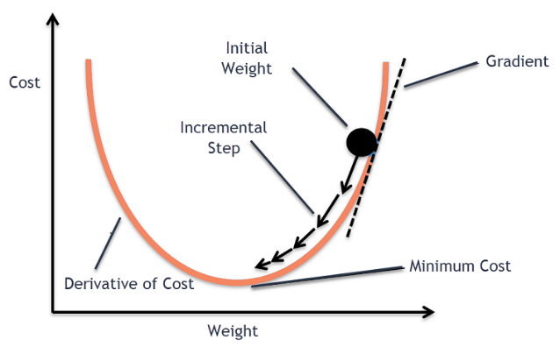

We are trying to find out the slope is positive or negative

Whenever the straight line which is passing through the line is pointing down, then it is a negative slope. When it is pointing up, then it is a positive slope.

Simply after drawing the line, we can see the slope line. If the slope line is going towards the downside, then it is a negative slope. Or if the slope is travelling towards upside, then it is a positive slope.

here this blue point on the slope line is the loss function value point on the graph

then our main aim to reach the global minima point for better accuracy, unless we reach the global minima, the weight updating will happen continuously with back propagation and forward propagation. If the loss value is decreasing, which means we are reaching to the global minimum If the loss value is not decreasing, which means our point is rotating in the slope itself with help performing rate, So we need to manipulate the learning rate.

**Case 1: Negative value**

If we have a negative value in the slope. And we need to reach the global minimum And when we using the formula of weight updation.

***w new = w4 old – η \**** ∂***L/***∂***w4***

here *∂L* becomes negative value (- Ve)

*∂L =* value (- Ve)

So (-) * (-) = Positive

Which means w4 old + new positive value

Ex: old value = 1; by adding a positive value it will be more then 1 right. So, the point moves to the right which means value is increasing.

New Value = 4

Old Value= 3

1 2 3 4 5 6 7 8 9 10 11 12

**Gradient Descent Learning Rate**

**Moderate Learning**

**Most used = 0.001 Learning Rate**

Global Minima

Now old value is change to new value and the value is increased and getting near to the global minima

But how slowly and how fast the value should move is completely decided by the learning rate.

Old Value= 3

1 2 3 4 5 6 7 8 9 10 11 12

**Gradient Descent Learning Rate**

**Slow Learning**

Global Minima

Here in gradient descent. If there is a slow learning. Model might take lot of time to reach the global minimum. Of course, it will reach global minima But it takes lot of time, which is not good for the model.

Old Value= 3

1 2 3 4 5 6 7 8 9 10 11 12

**Gradient Descent Learning Rate**

**Fast Learning**

Global Minima

Here in this fast-learning gradient descent there is a high chance that learning rate might not reach the global minimum And get jump into here and there within the gradient descent. And it may not reach the global minimum though it is fast.

**Case 2: Positive value**

1 2 3 4 5 6 7 8 9 10 11 12

Old Value= 11

New Value = 10

**Gradient Descent Learning Rate**

**Moderate Learning**

**Most used = 0.001 Learning Rate**

Global Minima

***w new = w4 old – η \**** ∂***L/***∂***w4***

here *∂L* becomes negative value (+ Ve)

*∂L =* value (+ Ve)

So (-) * (+) = Negative

Which means w4 old - new positive value

Ex: old value = 11; by Subtracting a positive value it will be less than 11 right and it is 10. So, the point moves left side to 10th point.

Unless we reach the Global Minima, this Backpropagation works then weights get updated and then again forward propagation works. It will iteratively repeat until we reach the global minimum

Global minima = actual value (test value) or near to actual value

It works for entire dataset, if it is not reaching the global minimum, then there must be some issue with the formula. We are applying and we can conclude that this gradient descent may not work properly. For that, we have another option, like stochastic gradient descent

For more clarity 1st read Unsupervised ML Notes about Gradient Decent

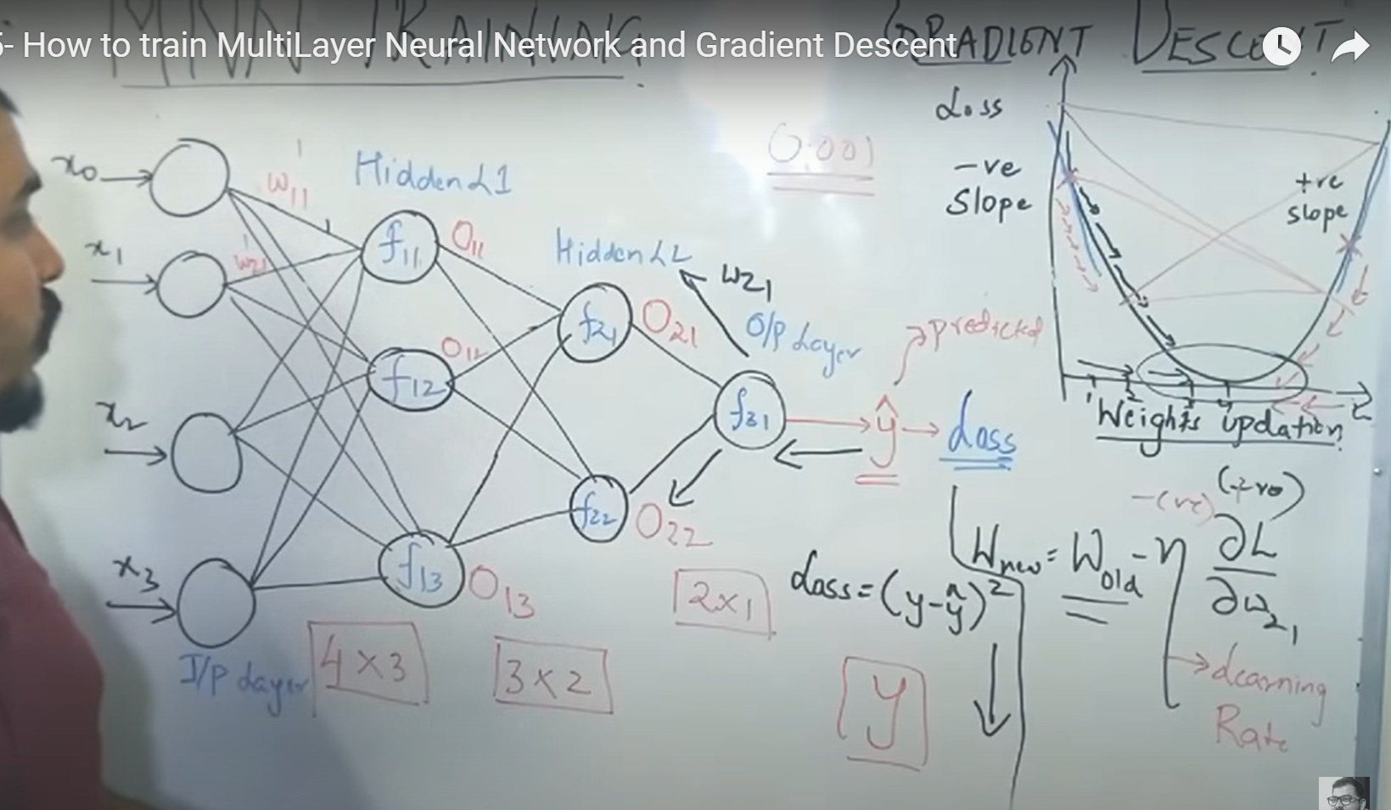

[Krish Naik Tutorial-5:](https://youtu.be/cxPAvoIbsIk)

**Chain Rule in Back Propagation:**

***w211***

***f11***

***O211***

***w213***

***w212***

***f21***

***w311***

***O311***

***f31***

***f12***

***w321***

***f22***

***O221***

***f13***

**Hidden Layers**

Chain rule of Differentiation with the back propagation.

Back propagation 🡪 predicted value 🡪 Loss Function 🡪 Optimizer

In Bach Propagation weights get updated using the Chain rule Differentiation

**chain rule: *f21* nodes weight updating *w311 New***

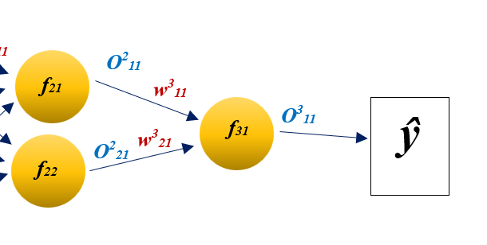

Blue arrow:

Indicates the node we are working or node’s weights we need to update

Red arrow:

Indicates the weight which we are working on

***w311 New* = *w311 Old – η*** 🡪 Slope

$\frac{∂L}{{∂w}_{11}^{3}}=\frac{∂L}{∂O_{31}^{3}}* \frac{∂O_{31}^{3}}{{∂w}_{11}^{3}}$

So, it reaches to the same

*But now*

$\frac{∂L}{{∂w}_{11}^{3}}=\frac{∂L}{∂O_{31}^{3}}* \frac{∂O_{31}^{3}}{{∂w}_{11}^{3}}$

This can get cancel (strike off) to simplify but we will not do that

It is just to enlarge the code

So, here we are using chain rule to update the weights with consideration of the output, which is dependent on the weight we are updating.

Now for next weight ***w321 New***

**chain rule: *f22* nodes weight updating *w321 New***

**

In The above process, which is updating the weights There is only one output effective which is $O_{31}^{3}$ And this is the last output So only it is affecting so that we are only adding this output in the chain rule.

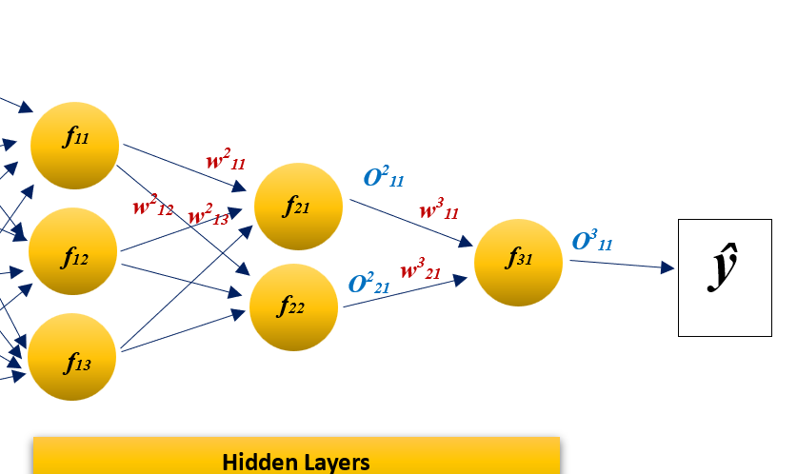

Now, ***w211***

**chain rule: *f11* nodes weight updating *w211 New***

***w211 New = w211 Old – η $\frac{∂L}{{∂w}_{11}^{2}}$***

***Now here this can go through 2 ways***

1. ***f21 to f31***
2. ***f22 to f31***

***so, to complete this chain rule we go with both the ways and used both ways of weights and outputs for updating the weight***

***f11 🡪 f21 🡪 f31 pink line of travel***

***f11 🡪 f22 🡪 f31 red line of travel***

$\frac{∂L}{{∂w}_{11}^{2}}=\frac{∂L}{∂O_{11}^{3}}* \frac{∂O_{11}^{3}}{{∂O}_{11}^{2}}* \frac{∂O_{11}^{2}}{{∂w}_{11}^{2}}$

*Now, add both the way of travel pink + red because this will go both the ways so, we need to add both of them together*

***Pink travel + red travel***

***f11 🡪 f21 + f22 🡪 f31***

**Steps are**

1. As it is a back proportion so start from the end point.
2. Obviously, for the end endpoint there is no bait We have only output value
3. Start derivation from that output value
4. Next output value (as we are coming from back, next means before one)
5. Go with next output values… and reach the weight which we wanted to update
6. End the derivation with the weight which we wanted to update.
7. Note: here we are considering all the outputs, but not all the weights which are coming in between from the end to the weight we wanted to update.

Krish naik: [Tutorial-6](https://youtu.be/CRB266Eyjkg)

**Vanishing Gradient Problem:**

This is a problem occurs when we try to implement sigmoid function in each hidden layer.

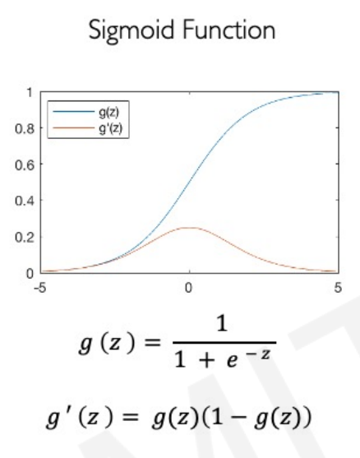

Here z is represented as the sum value of weights and bias

Y = z here.

Derivation of sigmoid

0 ≤ σ(z) ≥ 0.25

When we usually apply sigmoid function in derivation, I mean to say, when we apply sigmoid function in hidden layers as an Activation function. while we do derivation for updating the weights in back propagation (chain rule) we usually apply Activation function sigmoid, to Y value which is the summation of weights plus bias.

While we apply sigmoid function or an activation function to Y value. To get the output 0 or 1. But in back propagation it is different. When we apply derivation to the sigmoid function it range is change from 0 to 1, to it ranges only 0 to 0.25.

Ex:

***w211 New = w211 Old – η $\frac{∂L}{{∂w}_{11}^{2}}$***

Here, when we apply Sigmoid as an activation function, Due to the vanishing gradient issue or a problem Sigmoid drops its range. Derivation to sigmoid function, We are unable to see the big differ with new value and the old value of the weights.

***w211 New* ≈ *w211 Old***

let say,

***w211 Old***= 2.4

then using chain rule

***w211 New =***2.4- learning rate * [derivative (2.4)] 🡪 chain rule

***w211 New =*** 2.38

in this way we cannot see big change in the new value of weights while we are trying to update the weights using back propagation.

Krish Naik: [Tutorial 7](https://youtu.be/JIWXbzRXk1I)

**Exploding Gradient Problem:**

Here, the problem is not with the activation function, but the problem with the weights itself. In previous problem in previous vanishing gradient problem. We have a problem where almost all. New weight and the old weight are similar. So there is no big difference between new weight and the old weight Which means. The learning rate is way too slow. You change the weights in U curve of Learning Rate.

Here In exploding gradient problem, it is quite opposite to the previous problem which means it is way faster in learning weight on AU curve which means the new weight and old weight have huge difference.

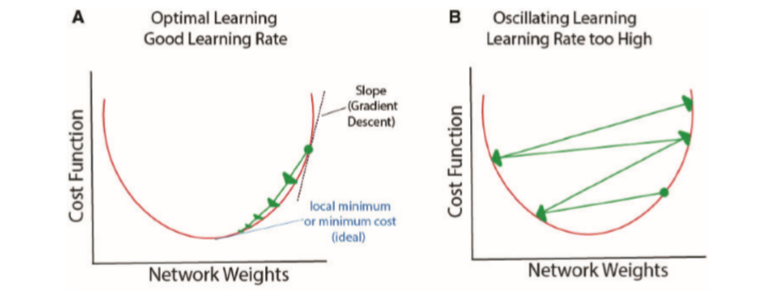

1. Varnishing Gradient Problem (too slow) to reach the value
2. Exploding Gradient problem (too fast) and go far from the value

Krish Naik: [Tutorial 8](https://youtu.be/IJ9atfxFjOQ)